

Site Manager CMS Template Guide

**Version: v10**

**Date: 05 September 2012**

**Author: Web CMS Team**

**Project: Web CMS Project**

Web CMS Templates

### Globally available templates:

1. Gl Page Content Main 3

2. Gl Further Content 4

3. Gl Main Section Index Box 6

4. Gl Page Callout 8

5. Gl Contact Details 1 - Main Office 9

6. Gl Contact Details 2 – Category 10

7. Gl Contact Details 3 – Person 10

8. Gl Google Map 11

9. Gl Google Map Point 13

10. Gl Table of Contents 1 - Children 15

11. Gl Table of Contents 2 – Sibling 16

12. Gl Table of Contents 3 – In-page 17

13. Gl FAQ 18

14. Gl Photo & Gl Photo Gallery 20

15. Gl Policy Documents 22

16. Gl Embed Video 24

17. Gl Embed Audio 26

18. Gl More/Less 28

19. Gl A to Z TOC 30

20. Gl A to Z Section 30

21. Gl Bulletin TOC, Gl Bulletin Category, Gl Bulletin Item & Gl Bulletin TOC logo 33

22. Gl Twitter Follow Button 36

23. Gl Footnote 37

24. Gl LinkedIn Follow Button 39

### Templates which are available on demand:

25. Gl QuickLinks Menu 42

26. Gl Slideshow 44

# 1. Gl Page Content Main

The ***‘Gl Page Content Main’*** template is the main template used for each section, and must always be used for the main page heading. This template inserts the page heading, introduction, image and body of content, additional templates can then be added later to the page.

Only the fields that are marked with * are compulsory. The ‘Name’ field is just for reference and does not display on the page.

* **Template:**

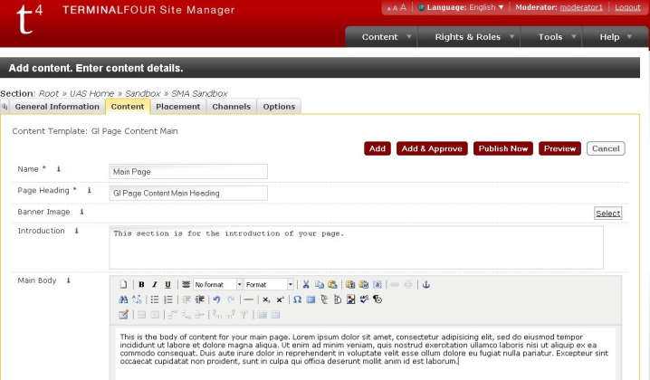

* 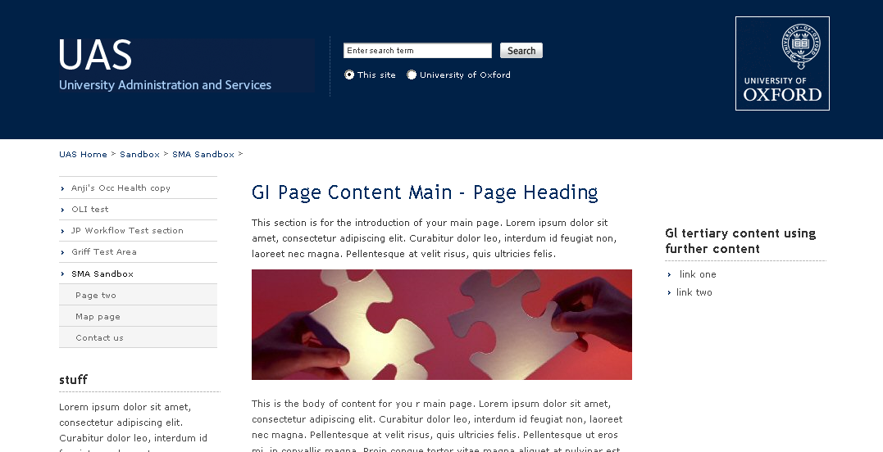**Preview:**

**Please note:** The page heading field is also used for the browser title bar.

# 2. Gl Further Content

The ***‘Gl Further Content’*** template is used to continue text after using a different template, e.g. the ‘Gl Page Callout’ template would be followed by further content.

* **Template:**

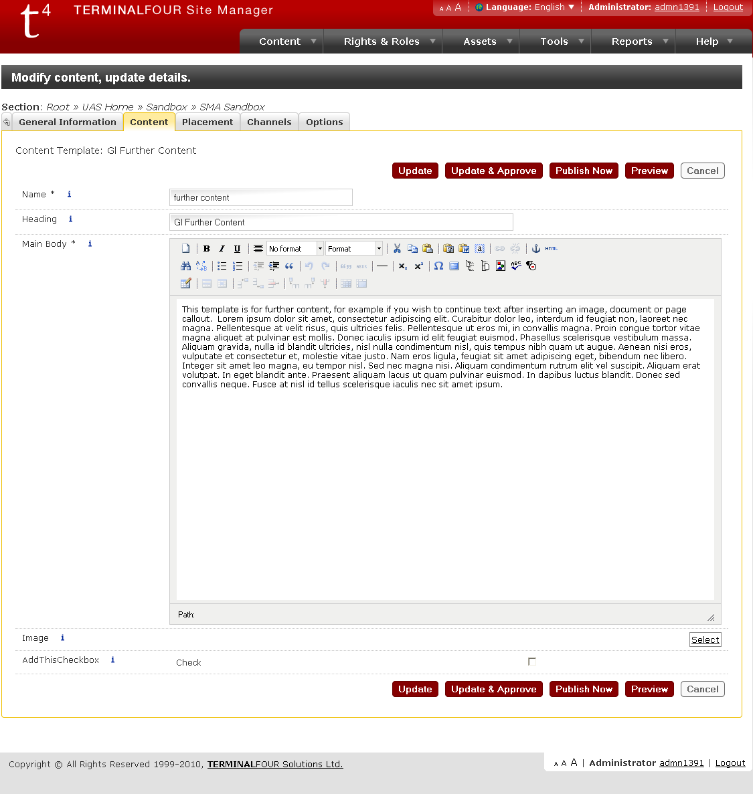

* **Preview:**

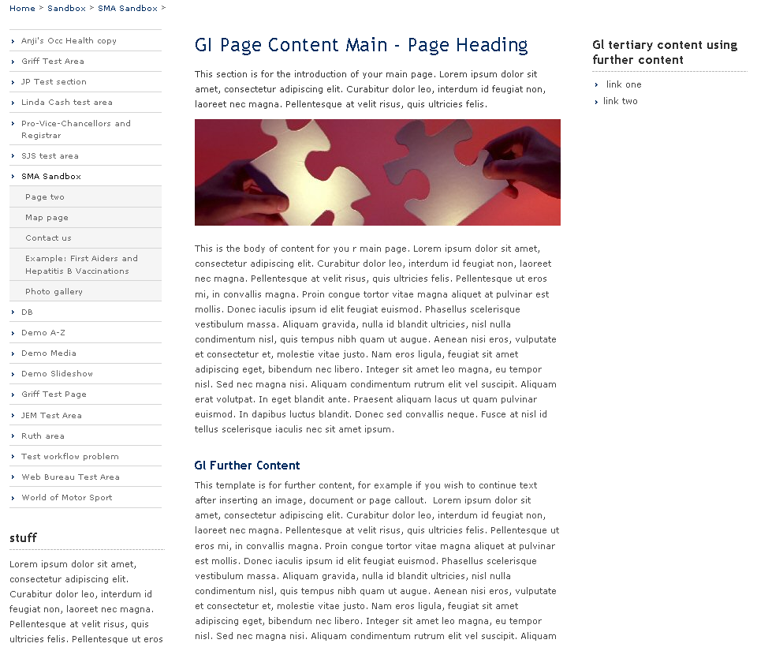

***‘Gl Further Content’*** is the template used in **secondary_content** and **tertiary_content** sub-sections. The secondary_content sub-section will be placed in column 1, below the left-hand navigation. The tertiary_content sub-section will be placed in column 3.

***‘Gl Further Content’*** template can optionally add an image to the top of the tertiary_content section.

***‘Gl Further Content’*** template can also optionally add a link to AddThis to the bottom of the tertiary_content. AddThis is a social bookmarking service. Once AddThis is added to a web page, website visitors can bookmark an item using a variety of services, such as Facebook, MySpace, Google Bookmarks, and Twitter.

# 3. Gl Main Section Index Box

The ***‘Gl Main Section Index Box’*** template allows you to insert text and imagery into index listings for areas of your website. Typical use is for an enhanced visual index to a sub-area of a site, i.e. a main section of the site.

* **Template:**

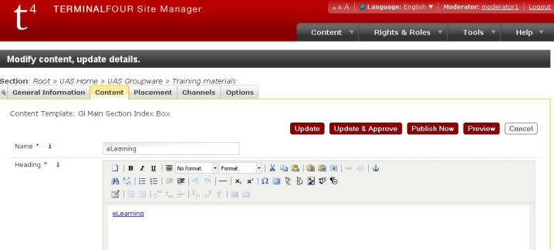

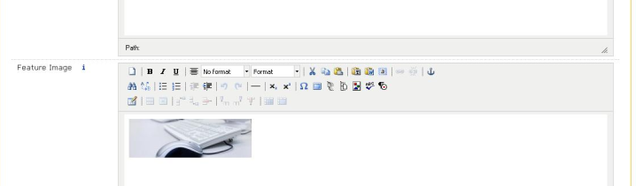

* **Preview:**

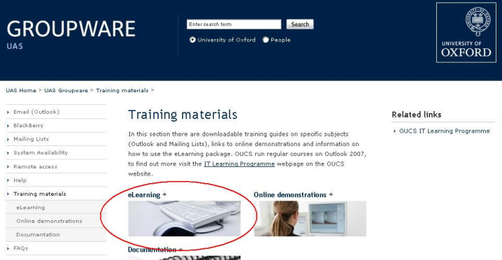

**The size of two images placed side by side is: 215 x 62 pixels (width x height)**

**The size of one image spanning both columns is: 459 x 62 pixels**

# 4. Gl Page Callout

The ***‘Gl Page Callout’*** template is used to insert quotations to the webpage.

* **Template:**

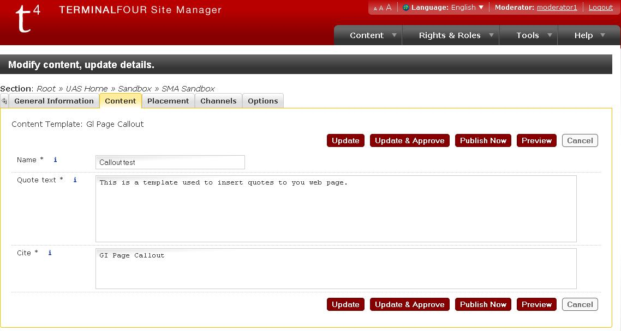

* **Preview:**

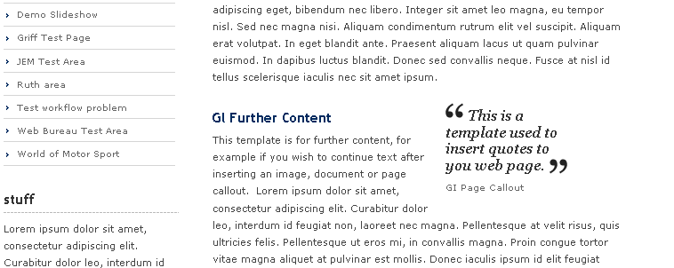

If you would like text content to wrap around the callout, the text must go into further content template following the callout template.

# 5. Gl Contact Details 1 - Main Office

The ***‘Gl Contact Details 1 – Main Office’*** template is used to insert organisational contact information.

* **Template:**

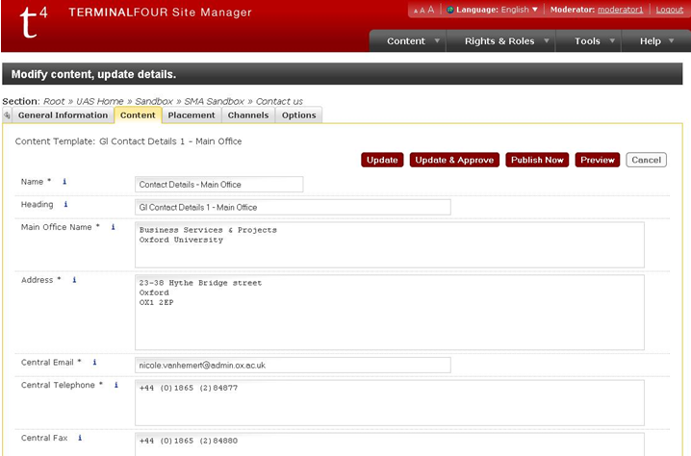

* 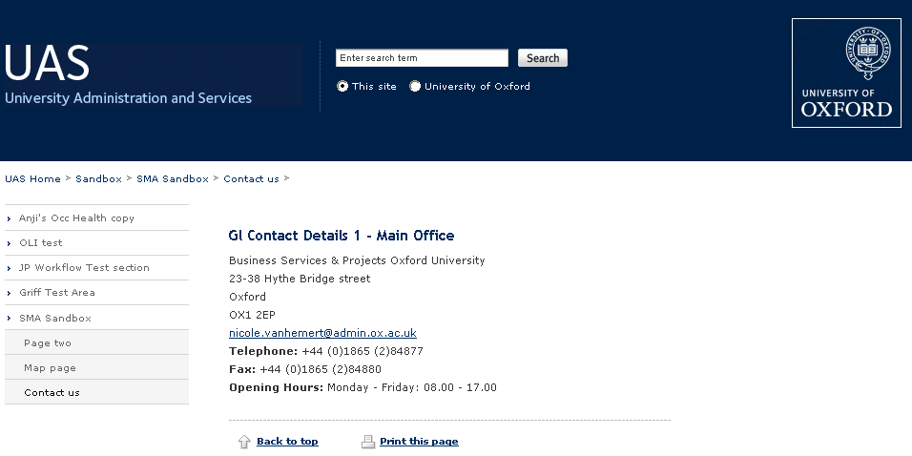**Preview:**

# 6. Gl Contact Details 2 – Category

The ***‘Gl Contact Details 2 – Category’*** template is used to split contact details into individual divisions or groups within an organisation.

# 7. Gl Contact Details 3 – Person

The ***‘Gl Contact Details 3 – Person’*** template is used to insert the details of an individual and provides more fields to enter data.

With this template you can use as many fields on the page as needed, using various contact details templates in combination.

* **Template:**

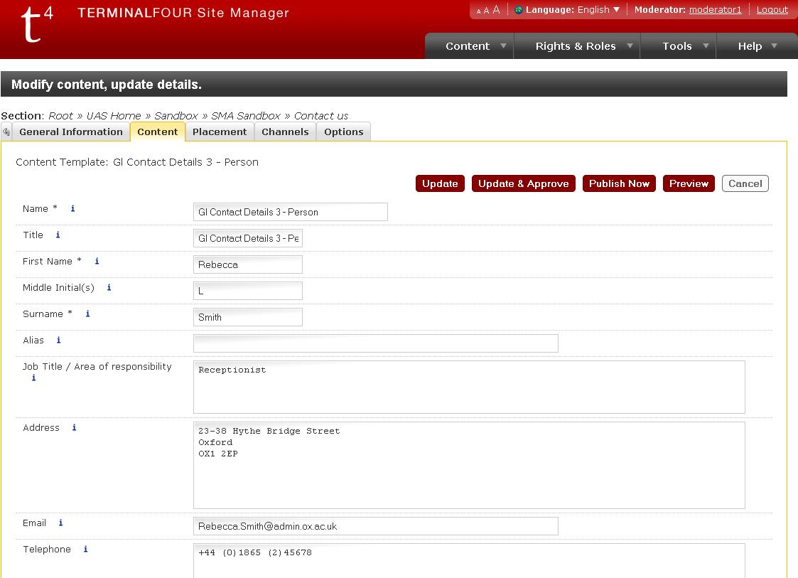

* 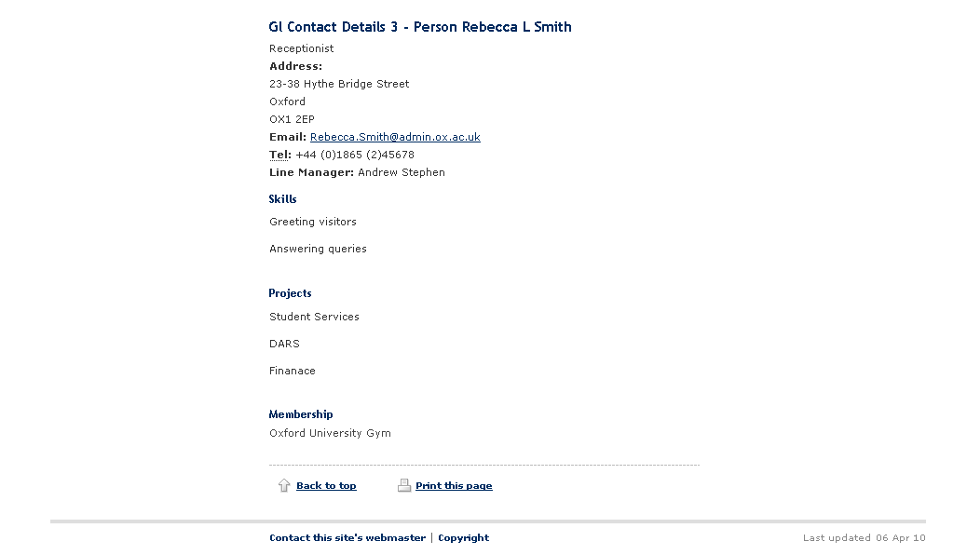**Preview:**

# 8. Gl Google Map

Using the ***‘GI Google Map’*** template and Google coordinates, this template allows you to insert a map image onto the webpage.

This template must be used only on webpages which are publicly viewable. The pinpoints cannot be loaded on pages which are access restricted.

* **Template:**

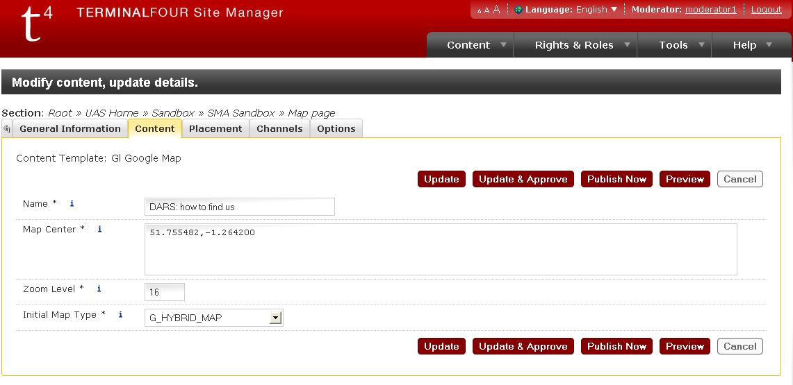

* **Preview:**

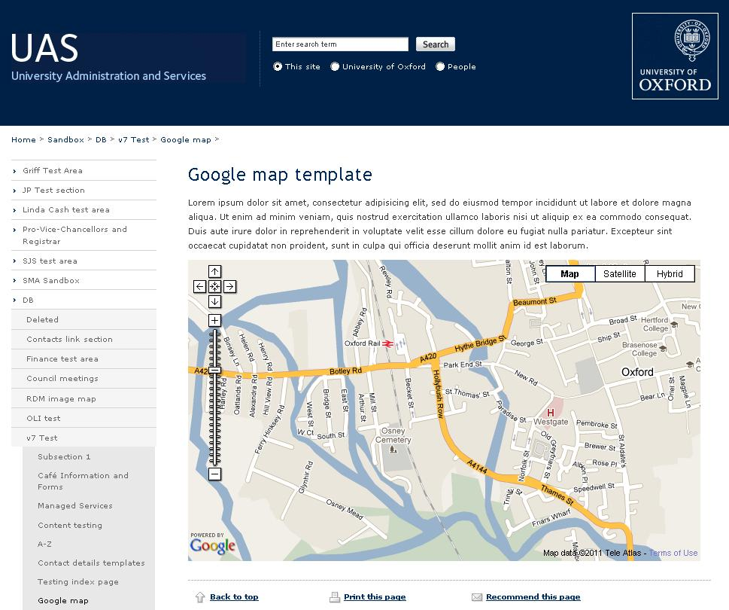

The common zoom level is 16, and the map centre coordinates can be found by right clicking on the map in Google, then select ‘what’s here’. This will insert the coordinates into the search field at the top of the page.

Please note that in order to zoom out you need to decrease the zoom level, and increase it in order to zoom in.

**Please note**: That the map will *not* display or work correctly in Preview if you’re adding it as new content. It will display correctly if you’re editing an already existing map.

# 9. Gl Google Map Point

The ***‘Gl Google Map Point’*** template pin points a location on the map, this template also gives the option for popup notes with further information to the pin pointed location.

This template must be used only on webpages which are publicly viewable. The pinpoints cannot be loaded on pages which are access restricted.

* **Template:**

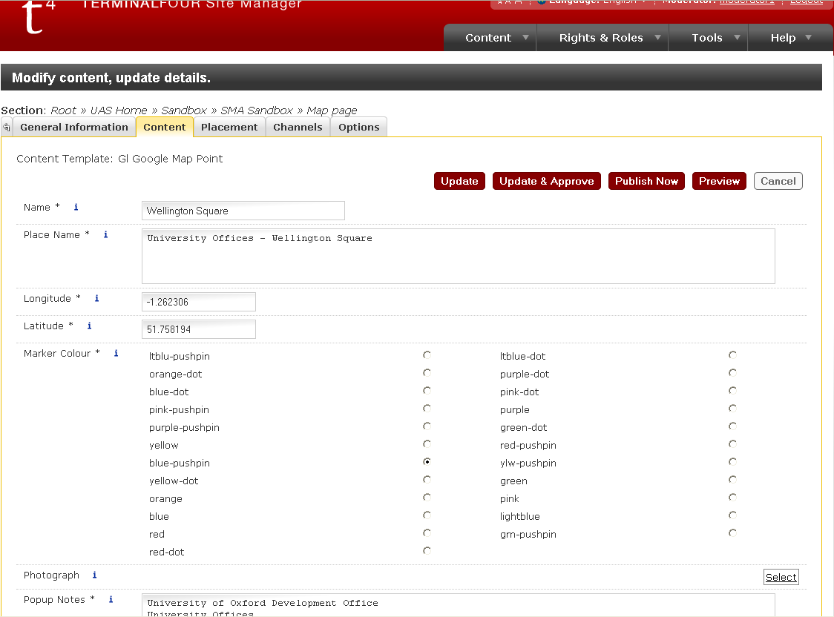

The longitude and latitude coordinates can be found by right clicking on the map in Google, then select ‘what’s here’. This will insert the coordinates into the search field at the top of the page.

Please make sure you enter the coordinates in the correct fields (Google maps and most other online maps will display them the other way around – latitude first and longitude second).

* **Preview:**

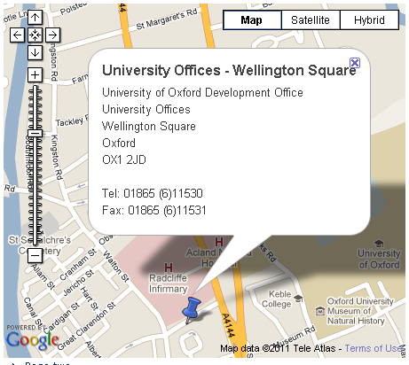

**Please note** that if you add a photograph, it should be categorised in the Media Library as type ‘Generic’, not ‘Image’.

**Please also note** that the map points will *not* display or work correctly in Preview.

A copy of this template will need to be used to add additional map points.

# 10. Gl Table of Contents 1 - Children

The ***‘Gl Table of Content – Children’*** provides a list of links to pages which are the children of the page you are currently viewing in the site hierarchy.

* **Template:**

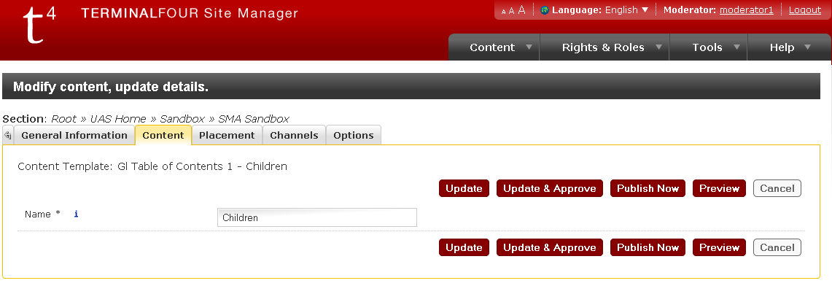

* **Preview:**

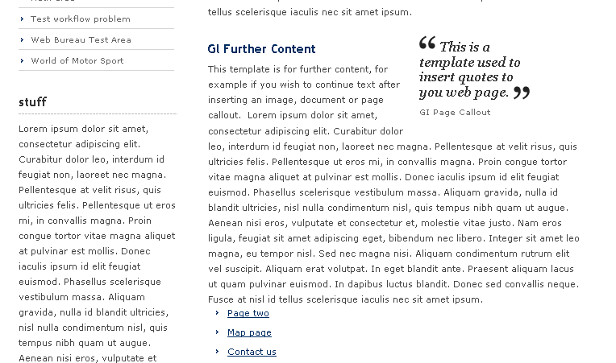

# 11. Gl Table of Contents 2 – Sibling

The ***‘Gl Table of Content – Siblings’*** plays the same role as ‘children’, however will show pages at the same level as the page currently being viewed.

* **Template:**

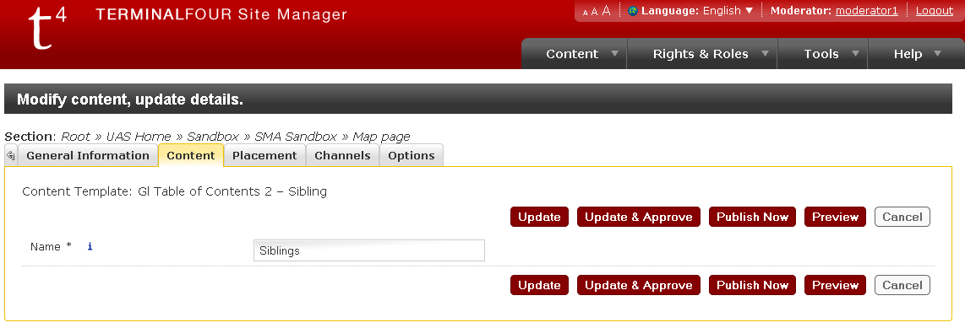

* **Preview:**

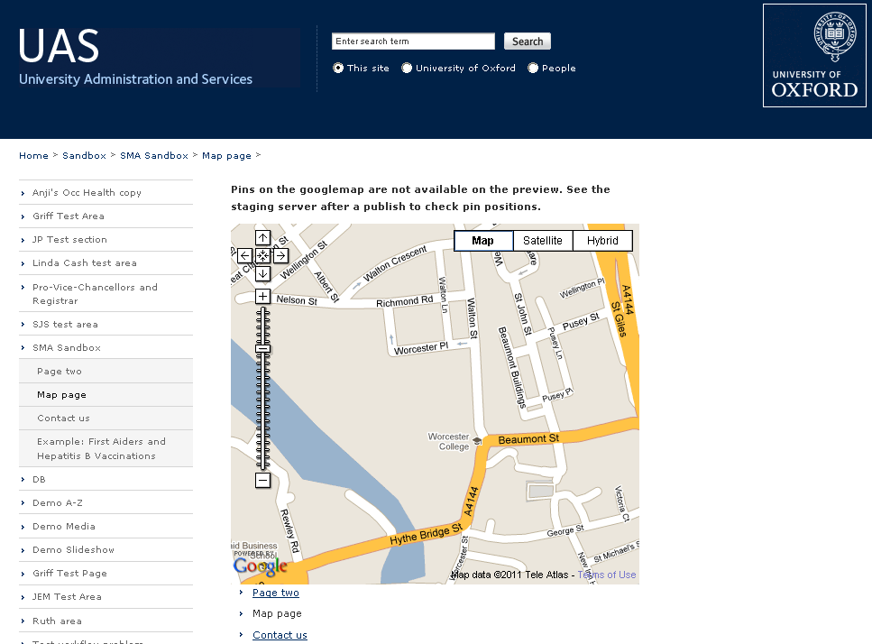

# 12. Gl Table of Contents 3 – In-page

* **Template:**

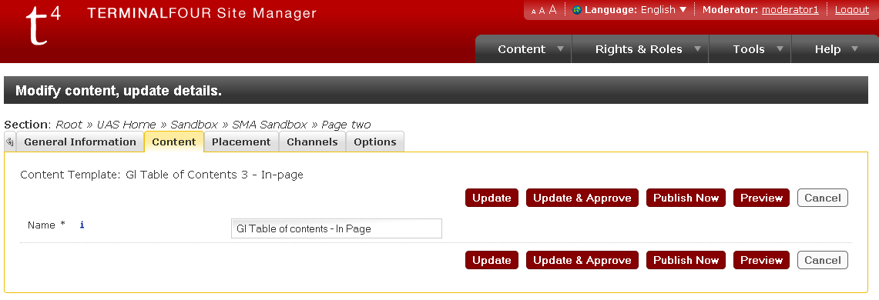

* **Preview:**

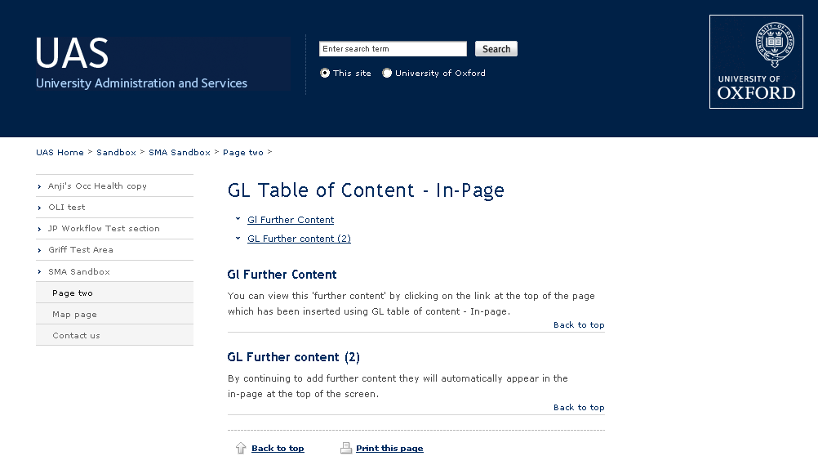

After inserting ***‘Gl Table of contents 3 - In-page’*** it automatically picks up the headings from added ***‘Gl Further Content’*** and ***‘Gl FAQ’*** content items, providing links at the top of the page that will take you directly to the content you wish to view.

This is useful for a long page of text, as it allows users to skip down the page. For content placement, a minimum of 3 templates need to be used together. These are: Gl Page Content Main, Gl Table of Contents 3 – In-page and Gl Further Content (or Gl FAQ).

# 13. Gl FAQ

***‘Gl FAQ’*** is an interactive show/hide template for presenting frequently asked questions, supporting the use of images in the answer field. Questions must be entered as Heading 3 elements, and all other content should be contained within a paragraph or list element. Images can remain outside paragraph tags.

* **Template:**

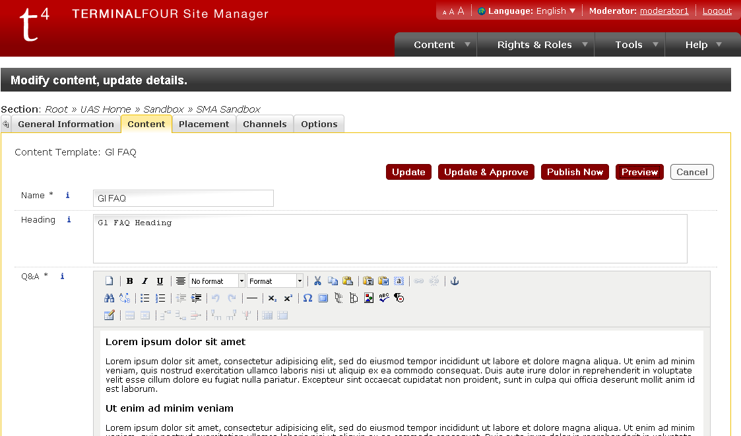

* **Preview:**

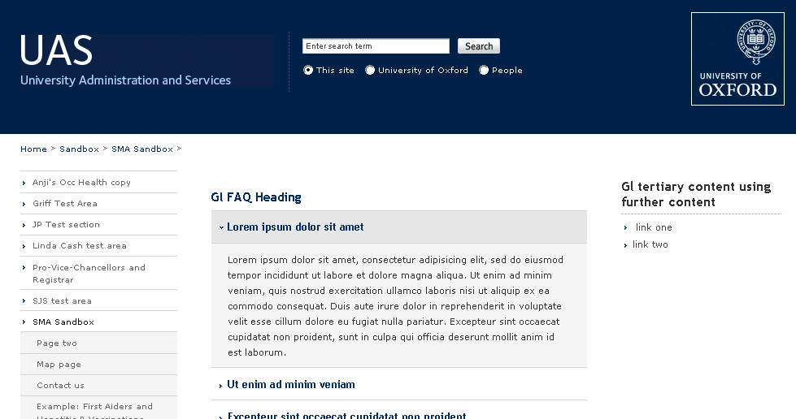

When content is placed in the ‘Heading’ field of the ‘Gl FAQ’ template, and a ***Gl Table of contents 3 - In-page*** template is added as the first content item, this will be displayed at the top of the page, providing a link down to the relevant FAQ list:

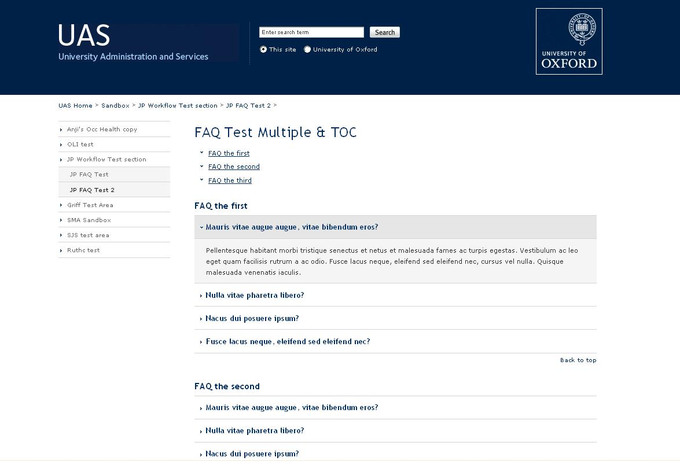

# 14. Gl Photo & Gl Photo Gallery

The***‘Gl Photo’*** and ***‘Gl Photo Gallery’*** templates are used to add a next/previous light box pop-up gallery of images to a webpage.

* **Template** **Photo** **Gallery:**

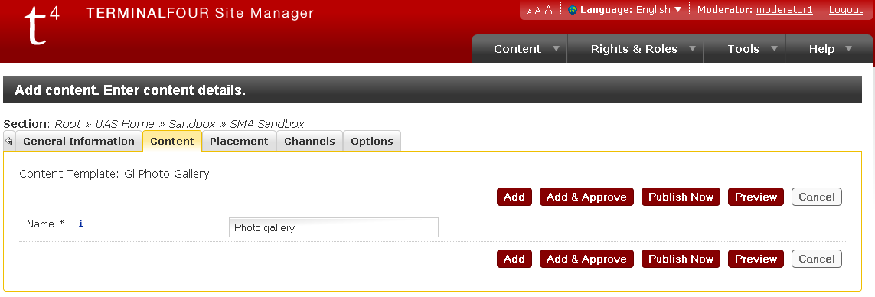

* **Template Photo:**

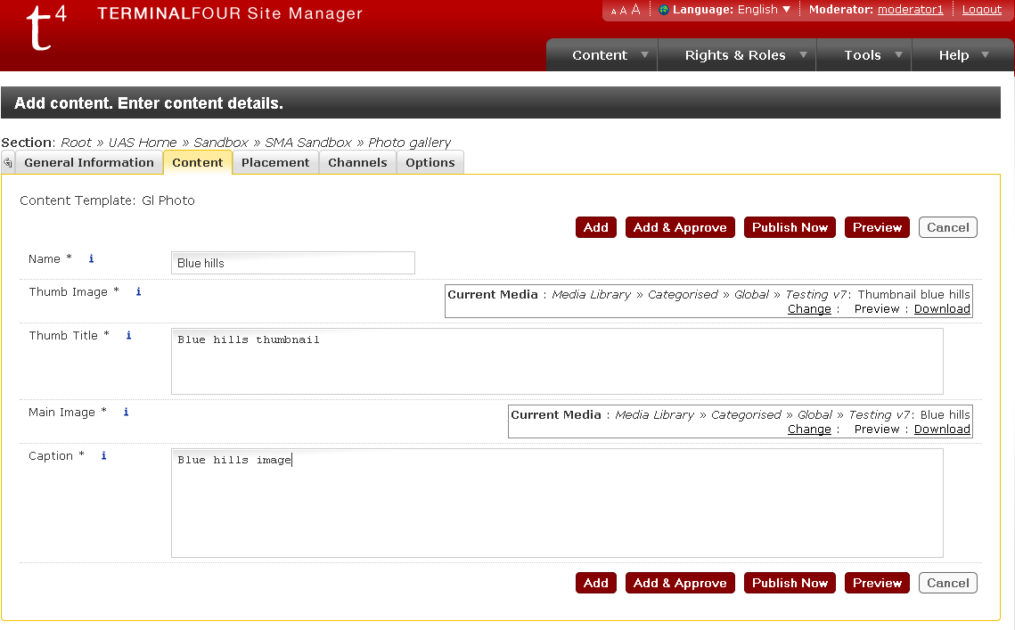

* **Preview:**



A copy of the Gl Photo template must be used for each image to be included, with a single copy of the Gl Photo Gallery template following.

Please note: When linking to pages with photo gallery content people should link to the section (using the section link option), rather than directly to content within the page (content links).

# 15. Gl Policy Documents

The ***‘Gl Policy Documents’*** template is used for the consistent layout of policy circulars/memos.

* **Template:**

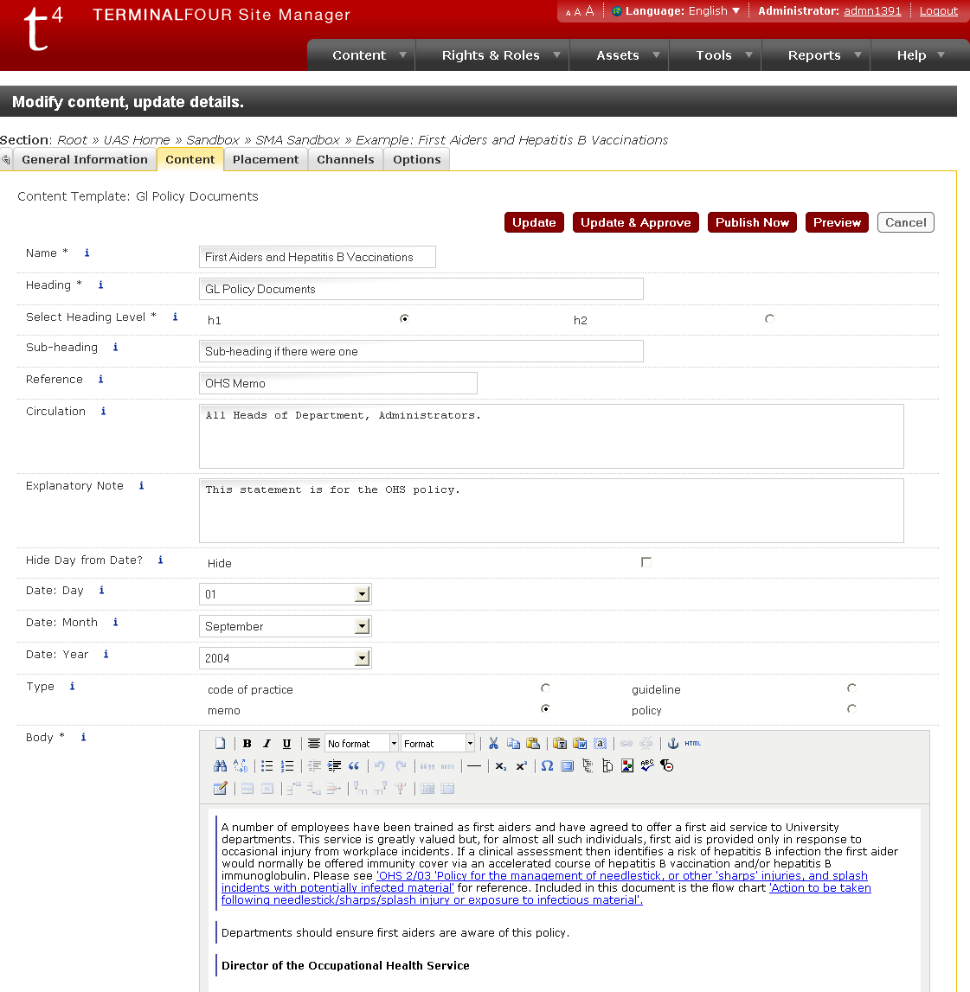

* **Preview:**

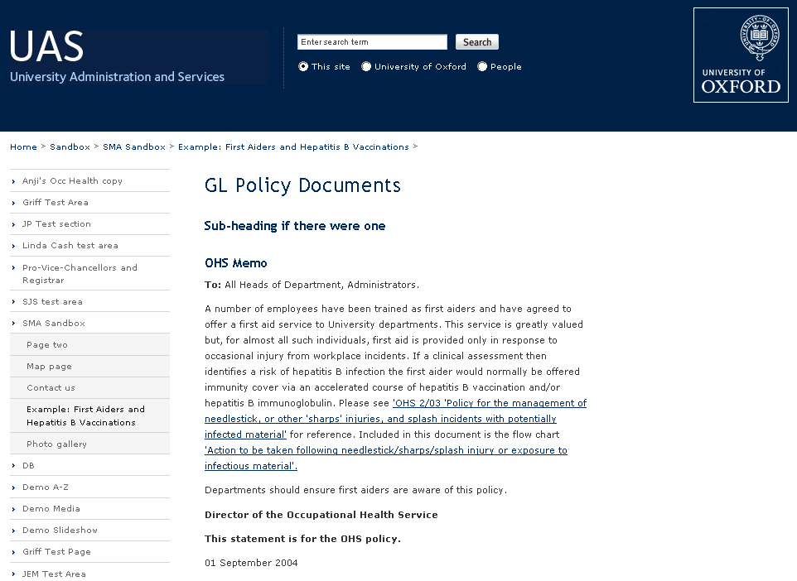

**Please note:** This template should not be used with an In-Page table of contents.

# 16. Gl Embed Video

The ***‘Gl Embed Video’*** template is used to add a video clip (.m4v, .mov, .f4v, .flv, .3gp, .3g2) in a flash player.

* **Template:**

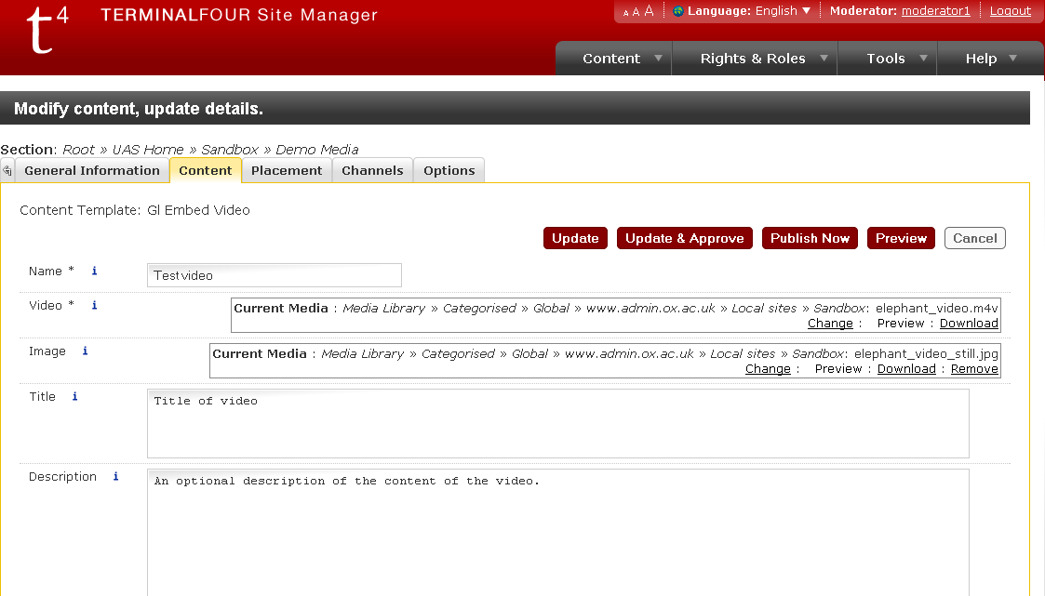

Before a video clip can be used in this template, it must be added to the Media Library **with its ‘type’ set to ‘Media Path’** (*not* ‘Video Clip’). An optional still image can be provided as well, to display before the player is started; this must also be added to the Media Library first, again with its ‘type’ set to ‘Media Path’ (*not* ‘Image’). If no still image is provided, the video player will just show a black screen with a ‘play’ button. A title and description for the video can also be provided (both are optional).

If the user does not have Flash enabled, they will see a link to download Flash from the Adobe site, and also a link to download the video file.

**Please note:** the flash player will *not* display or work correctly in Preview.

* **Preview:**

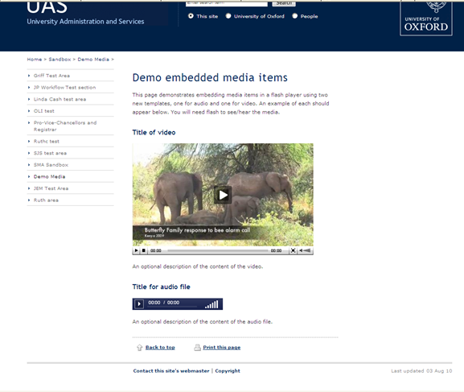

# 17. Gl Embed Audio

The ***‘Gl Embed Audio’*** template is used to add an audio clip (.mp3) in a flash player.

* **Template:**

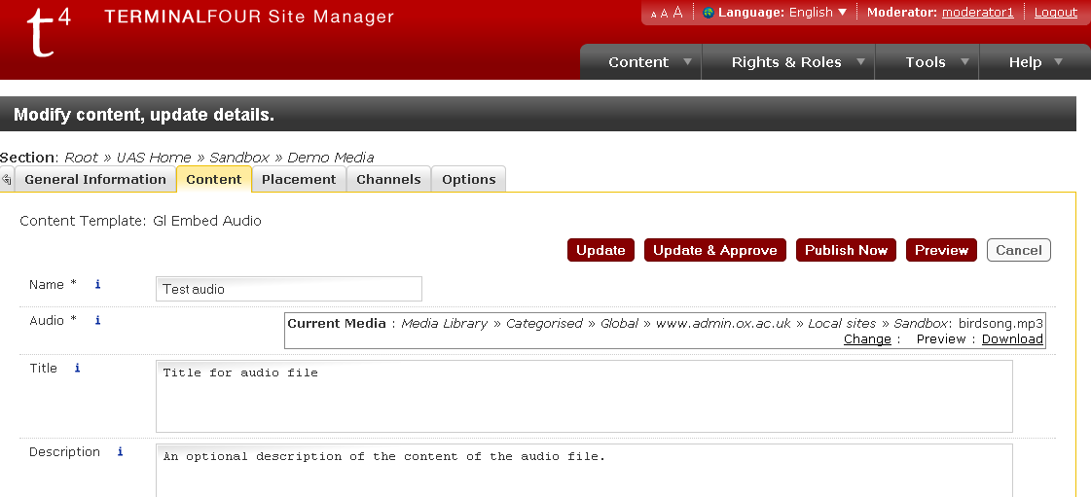

If the user does not have Flash enabled, they will see a link to download Flash from the Adobe site, and also a link to download the audio file.

Before an audio clip can be used in this template, it must be added to the Media Library **with its ‘type’ set to ‘Media Path’** (*not* ‘Audio File’). A title and description for the audio clip can also be provided (both are optional).

**Please note:** the flash player will *not* work in ‘preview’.

* **Preview:**

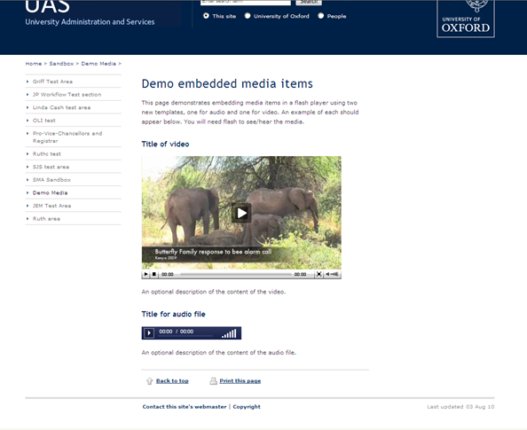

# 18. Gl More/Less

The ***‘Gl More/Less’*** is an interactive template for presenting or hiding items of content. A block of text can be expanded using the ‘More’ link, and hidden again using the ‘Less’ link. The ‘More/Less’ link will be appended to the sub-heading if present, or the main heading if sub-heading is not used.

* **Template:**

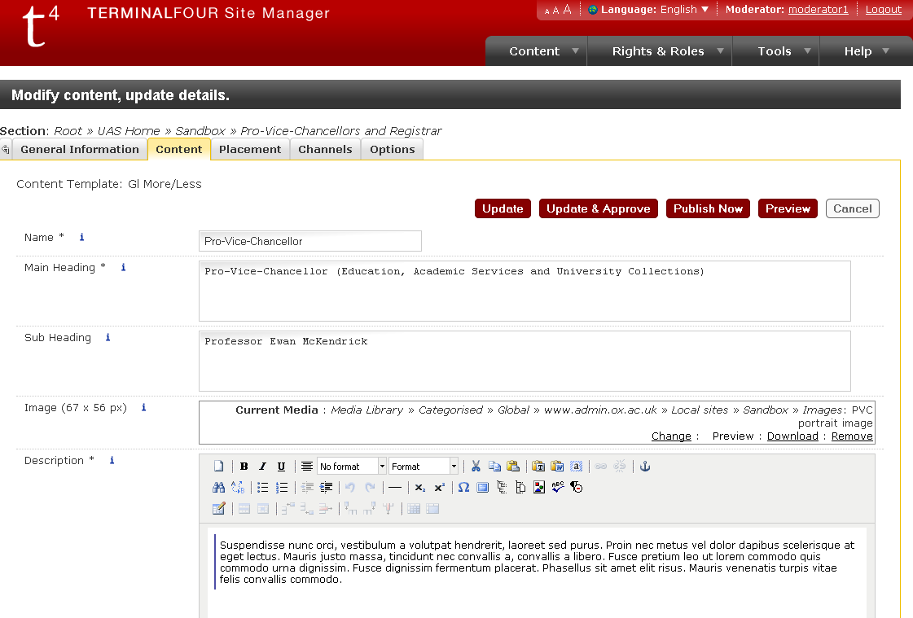

* **Preview:**

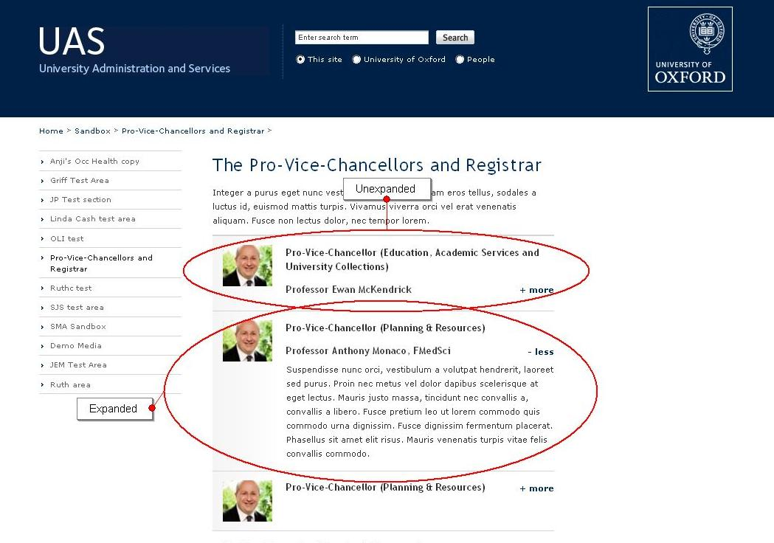

The thumbnail image used in the template should always have the dimensions of 67 by 56 pixels. If no image is added, the text will align to the left of the template (with padding) and no grey fade background is used:

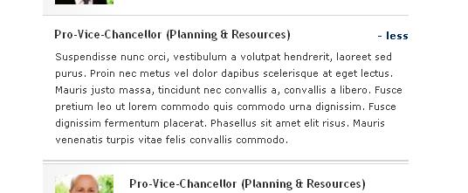

**Please note** that there are two other versions of the More/Less template with bigger fields. These are available on request.

# 19. Gl A to Z TOC

The ***‘Gl A to Z TOC’*** template is used to add a horizontal table of contents (ideal for letters of the alphabet for an A-Z list of links or section names) to a page. It is used in conjunction with ‘Gl A to Z Section’ (see below).

This template does not require any user input except a name for the item. Simply add it to a section and any ***‘Gl A to Z Section’*** content items in that section will be picked up by it.

# 20. Gl A to Z Section

The ***‘Gl A to Z Section’*** template is used to add sections to a page which will then be automatically linked to from a horizontal table of contents at the top of the page. This table of contents is generated with the ***‘Gl A to Z TOC’*** template (see above).

The content of the ‘Heading’ field will be used for the link in the table of contents (so for an A-Z this would be the letter of the alphabet for this section). The ‘last item’ box should be ticked if this section will be the last section on the page (this allows it to be styled differently).

An optional image can also be added – this will appear at the top of the section.

* **Template:**

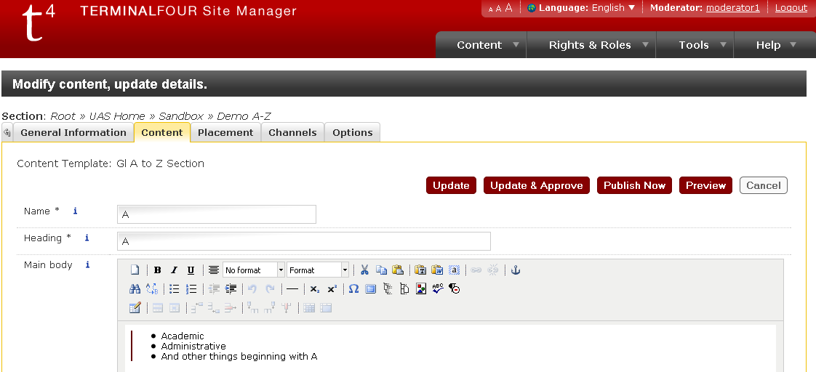

* **Preview (‘A to Z TOC’ with ‘A to Z section’):**

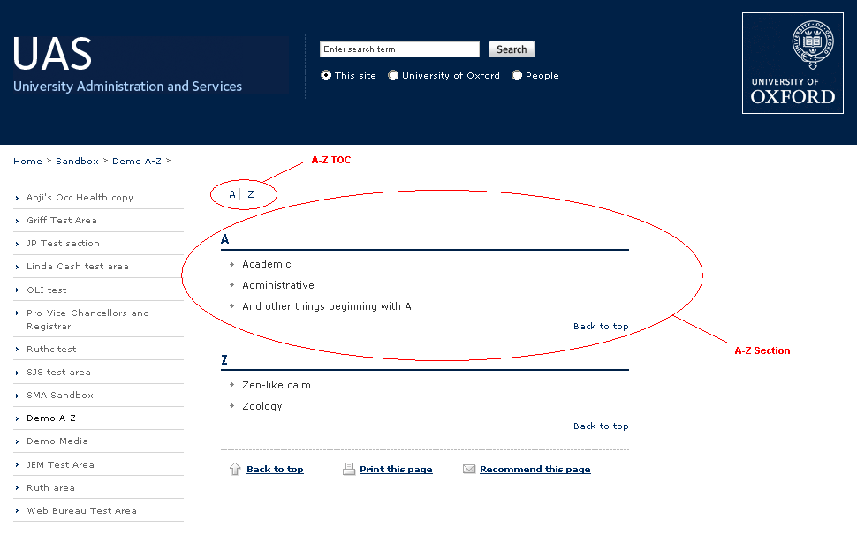

For an A-Z, you may want to ensure that when a new section is added it will appear in the correct alphabetical order (without having to reorder the sections manually); to do this, follow these steps (see screenshot below):

* go to the content section which contains your A-Z TOC and sections, and check the ‘Automatic ordering – Enabled’ checkbox at the top of the content section;
* in the “Automatic ordering” drop-down menu, select “Alphabetical (A-Z)”;
* move the A-Z TOC to the top of your content items, and use the ‘lock’ checkboxes to lock it in place (A-Z sections should remain unlocked);
* click the ‘save changes’ button at the bottom of the content section – you should see an alert saying “Sequence information changed successfully”.

Please see below screenshot for details:

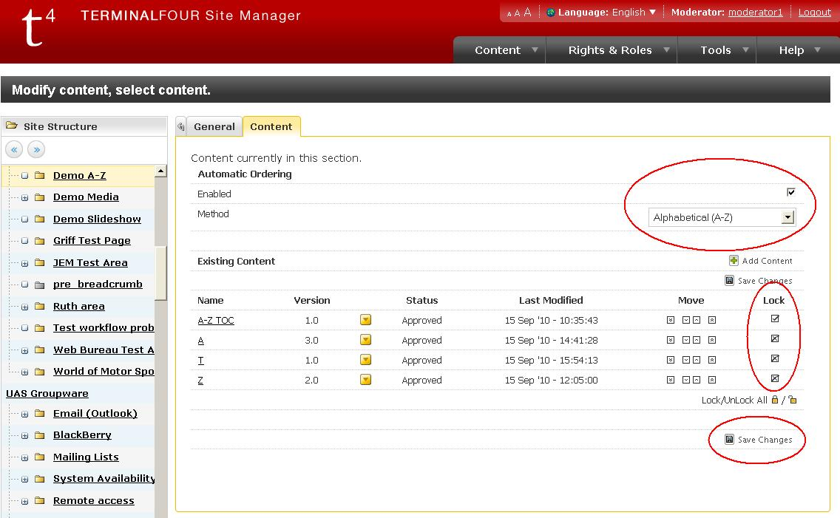

Now when you add a new section it will appear in the correct alphabetical order, both in the content section and on the resulting web page.

# 21. Gl Bulletin TOC, Gl Bulletin Category, Gl Bulletin Item & Gl Bulletin TOC logo

This template is used for creating an online Bulletin or Newsletter and associated version for sending to email lists. The email version optionally includes exactly the same content as the web version, or can be just a Table of Contents linking to the online version.

**Gl Bulletin TOC** – this template should be placed above the others and generates a dynamic table of contents for the page, including headings for categories if they are present.

**Gl Bulletin Category** – this template can be used to insert a Category heading into the page. This heading is displayed both within the main content as well as in the Bulletin TOC.

**Gl Bulletin Item** – this template can be used to add content items into a Bulletin.

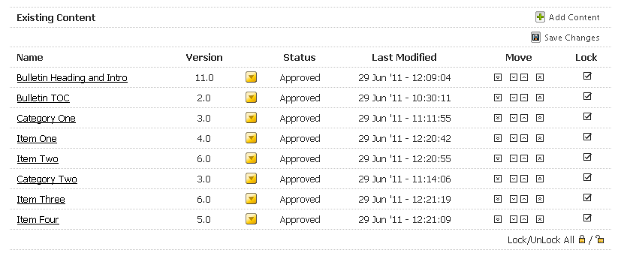

Please note that in the screenshot above, the content item ‘Bulletin Heading and Intro’ is using Gl Page Content Main to add the page title and some introductory text to the page. The resulting web page will appear as the following screenshot:

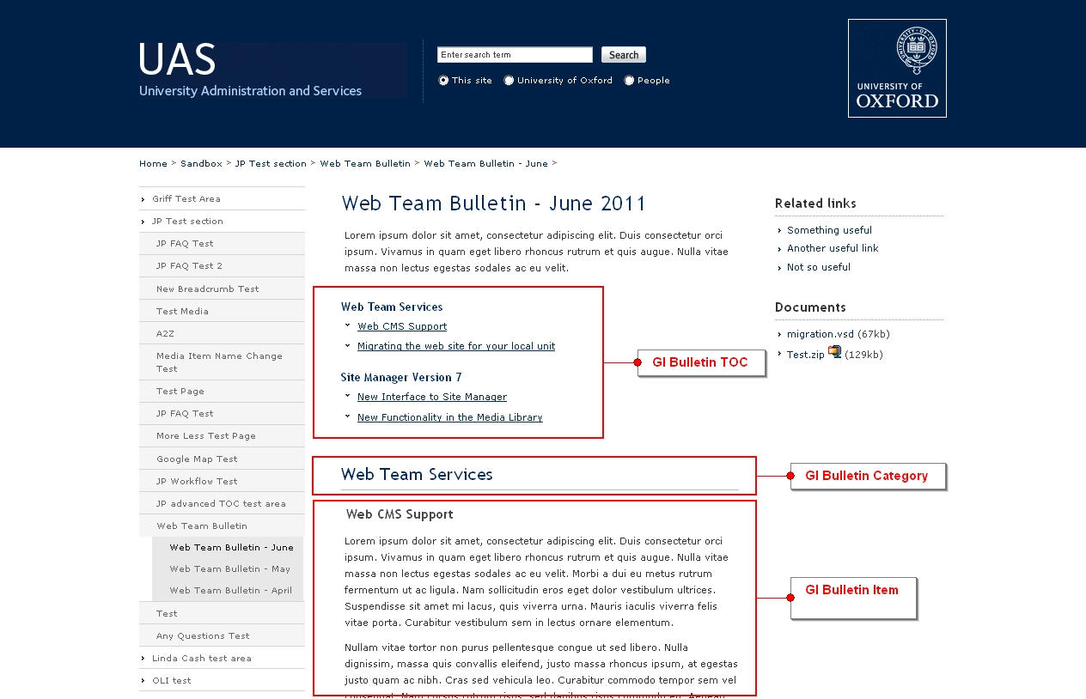

An email version of the page will also be produced:

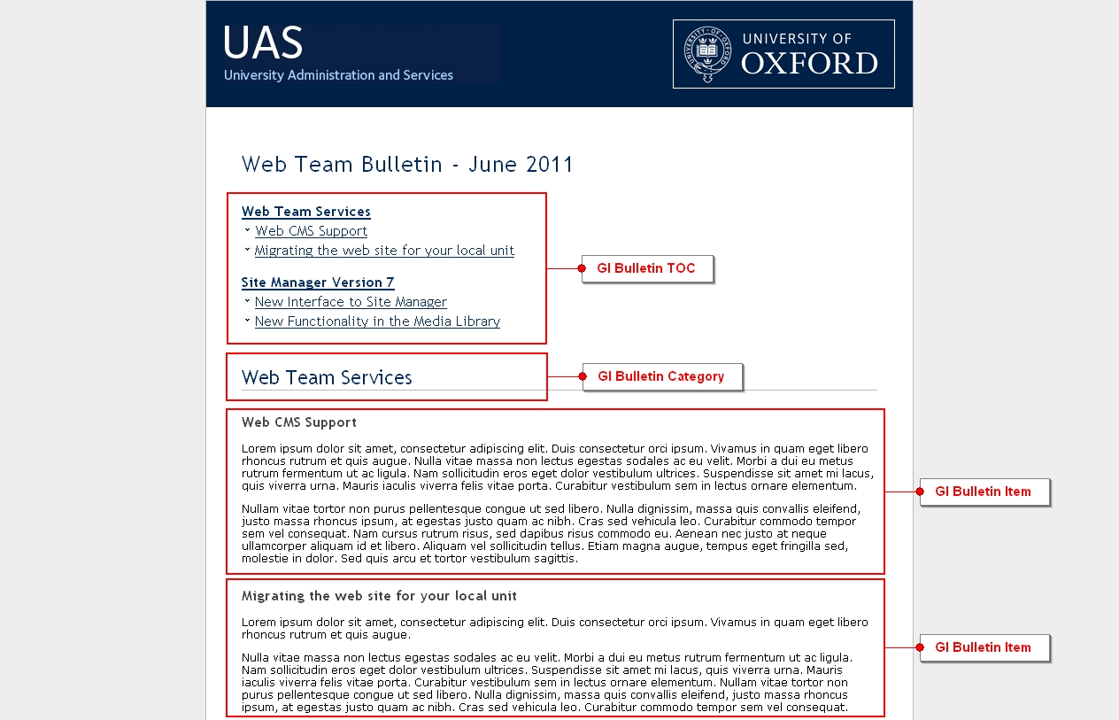

The email version of any bulletin page will be located beneath the same location on the web site, but named email.html instead of the web page’s usual index.html (the email version will always include the same oxonly protection as the content on the main page).

For example, for a page at http://staging.admin.ox.ac.uk/sandbox/bulletin/, the email version would be at http://staging.admin.ox.ac.uk/sandbox/bulletin/email.html .

The Gl Bulletin TOC template has a checkbox labelled ‘Full content in email’. If left unchecked, the email version will be output as a simple table of contents; if checked, it will output a TOC followed by the full content of the bulletin templates. The email version is published according to the usual publish/transfer schedule, and can also be triggered by running a ‘Publish Now’ on the relevant section.

Once you have located the email version of the bulletin, simply ctrl-a to select the page, and ctrl-c to copy it. This can then be pasted into Outlook or other email client (alternatively, just the TOC itself can be copied for the TOC Only version, and copied into your email).

Some points of note:

* The image in the top left will match the site’s heading image (shown in the top left of the web page). For non-adminweb sites, an image can be added via a grey section in Site Manager.
* If using the ‘Full content’ version of the bulletin email, the TOC links will need to be manually amended as they will be pointing to the web version of the page (an inevitable consequence of copy and pasting from the web version). The links will need to be deleted up to the ‘#’. For example, the following link:

http://staging.admin.ox.ac.uk/sandbox/jptestsection/bulletin/webteambulletin-june/#d.en.51986

Should be reduced (by editing the link) to just:

#d.en.51986

And this will ensure that it links to the relevant part of the email.

* Copy-and-paste to email strips out the html, head and body tags so you may need to add a background colour to the email (the grey background on the email.html file will not be copied). You can do this in Outlook by selecting ‘options’ then ‘Page colour’.
* Images – Images added to the web page via the WYSIWYG editor will not be ‘floated’ properly (with the text flowing around them) when copied into an email. This is a limitation of how email systems render HTML and stylesheets. Images can either be used as-is (without text flow), placed within table cells, or deleted.

As it is not best practice to use tables to place images on webpages, it may be advisable to amend such content, replacing it with floated images, after the email version has been used.

* The email version is not currently optimised for email clients on mobile devices.

The use of Gl Bulletin ToC Logo relates to the use of a logo for Oxweb sites, and/or the use of different logos for email and web output. This template should be used to replace the regular Bulletin TOC template in instances where the logo in the top-left of the header in the email version of the content should be different from that on the web version of the page. Please contact the Web Team on [webcms@admin.ox.ac.uk](mailto:webcms@admin.ox.ac.uk) if this is required.

# 22. Gl Twitter Follow Button

The Gl Twitter Follow Button template is designed to add a twitter ‘Follow’ button to a page, which allows users to easily follow your Twitter account. It can be used anywhere, but it is recommended that it be used in tertiary content.

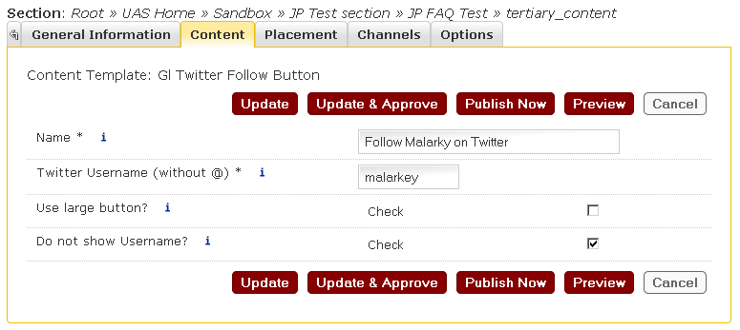

The Twitter username of the account that should be ‘followed’ should be added to the ‘Twitter Username’ field. Please note that the @ symbol should not be included in the username. Further options allow for either a small or large button to be added, or whether the button text should include the Username (see screenshot below, showing small button with no username, large button with no username, small button with username, and large button with username respectively).

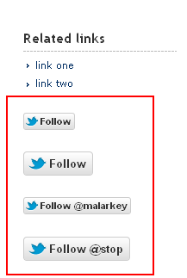

# 23. Gl Footnote

The Gl Footnote template is designed to allow the user to easily add and link to footnotes from within a page.

Footnotes should be added to the bottom of a page, one template for each footnote required. The footnote template should simply contain the name and text of the footnote:

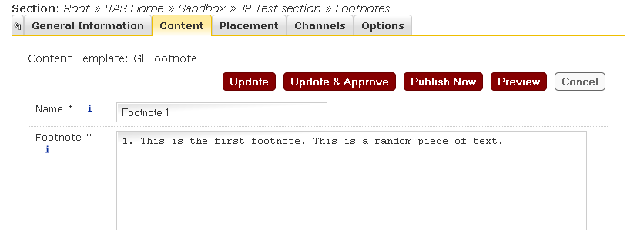

This content item can then be linked to from within the body text, using a content link, usually set as superscript:

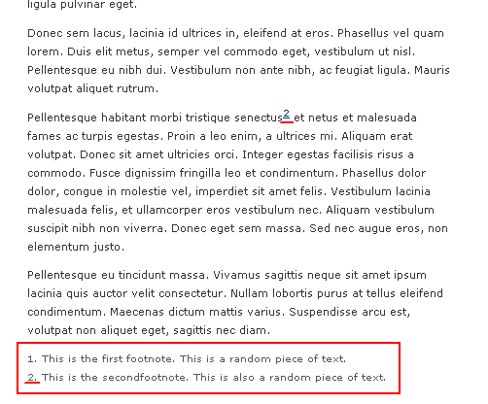

Please note that the current footnote template does not allow provide a link back up to the relevant part of the content (though this is on the roadmap for development).

## 24. Gl LinkedIn Follow Button

The Gl LinkedIn Follow Button template is designed to add a LinkedIn ‘Follow’ button to a page, which allows users to easily follow your organisation on LinkedIn. It can be used anywhere, but it is recommended that it be used in tertiary content.

* **Template**

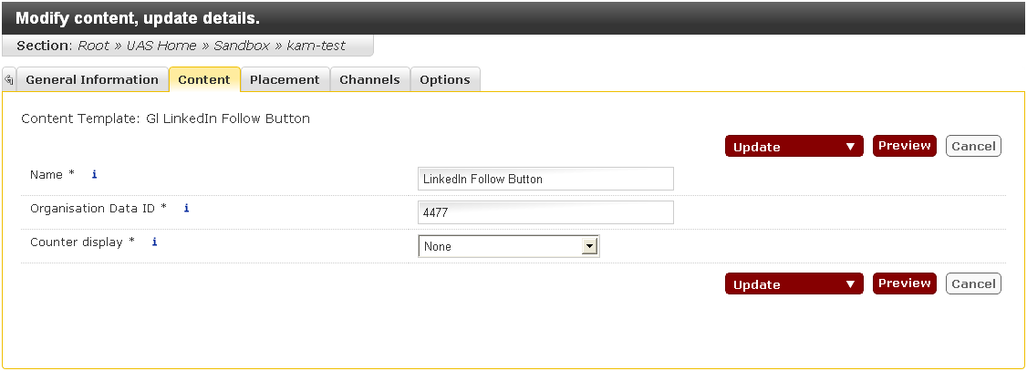

* **Preview:**

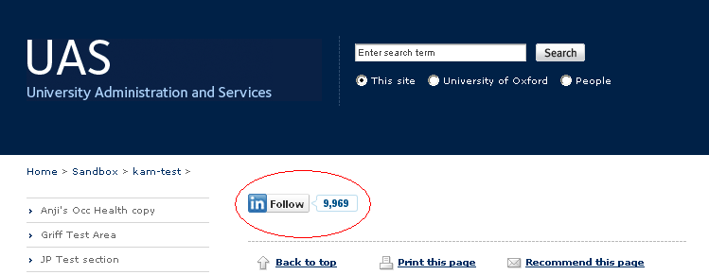

The data ID of the ‘company’ (in LinkedIn terminology) to be ‘followed’ should be added to the ‘Organisation ID’ field. This ID can be taken from the LinkedIn website using the following steps:

1. Login to LinkedIn with your account details and hover your mouse over the ‘companies’ link on the navbar and click ‘Search Companies’ from the list.  
   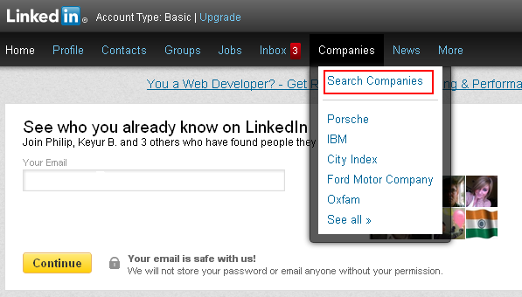
2. Once on the search screen enter your Organisation’s (Company) name or select your organisation from the list that appears as you begin typing. See figure below:  
   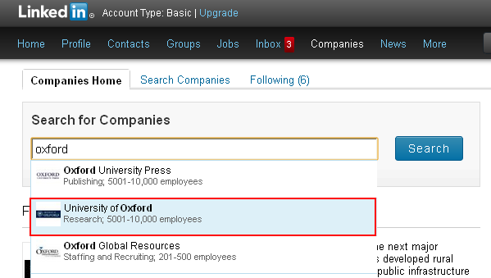
3. On your organisation’s page on LinkedIn, make a note of the last number in the browser’s address bar: this is the company’s data ID.

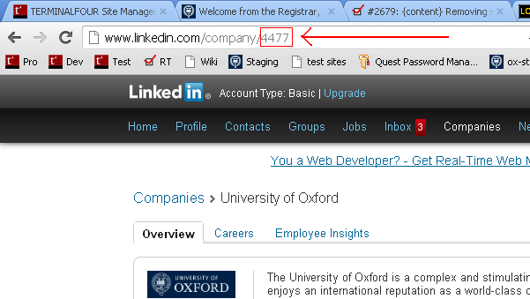

The ‘Counter display’ dropdown menu is used optionally to display your LinkedIn Organisation page's follower count. A counter can be displayed on the top or right of the follow button: to display it on the top choose ‘Above’; to display it on the right choose ‘Right hand side’. If you don’t want the counter to be displayed at all then leave the default ‘None’ option selected.

## 25. Gl QuickLinks Menu

The ***‘Gl QuickLinks Menu’*** template is used to add a drop-down menu of links to the left (secondary_content) or right (tertiary_content) sidebar.

Use the WYSIWYG editor to add a bulleted list of hyperlinks; this will automatically be turned into a drop-down menu. A title, a small amount of explanatory text, and a link to all the links on a separate page may all be added as well (these elements are optional).

The background colour of the menu can be changed by selecting an option from the list; the default is beige.

* **Template:**

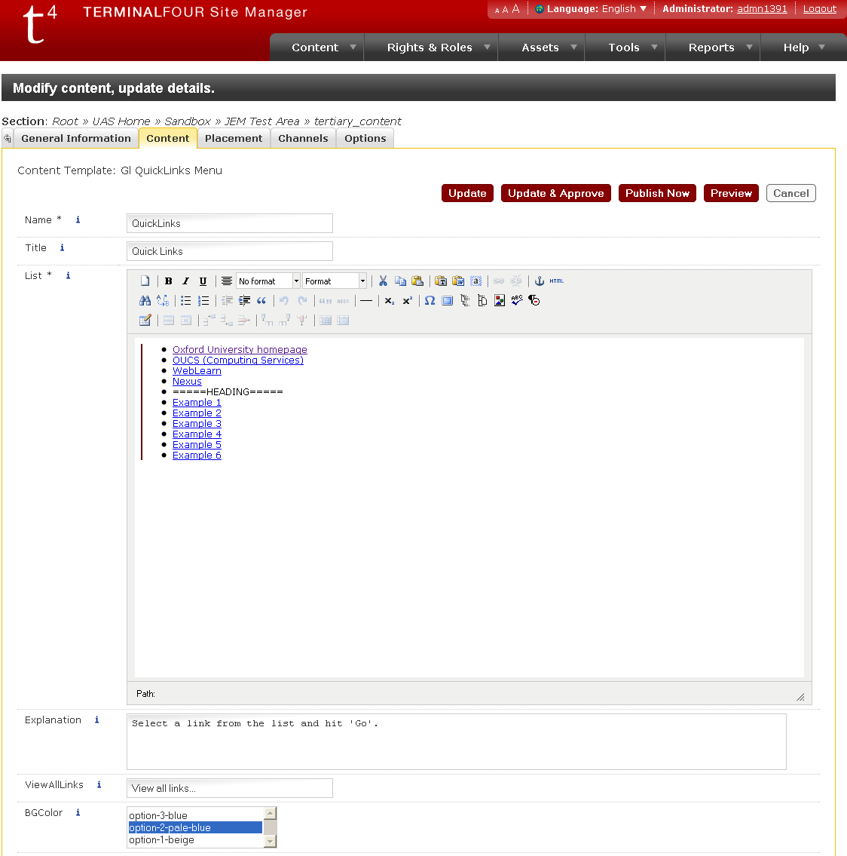

* **Preview:**

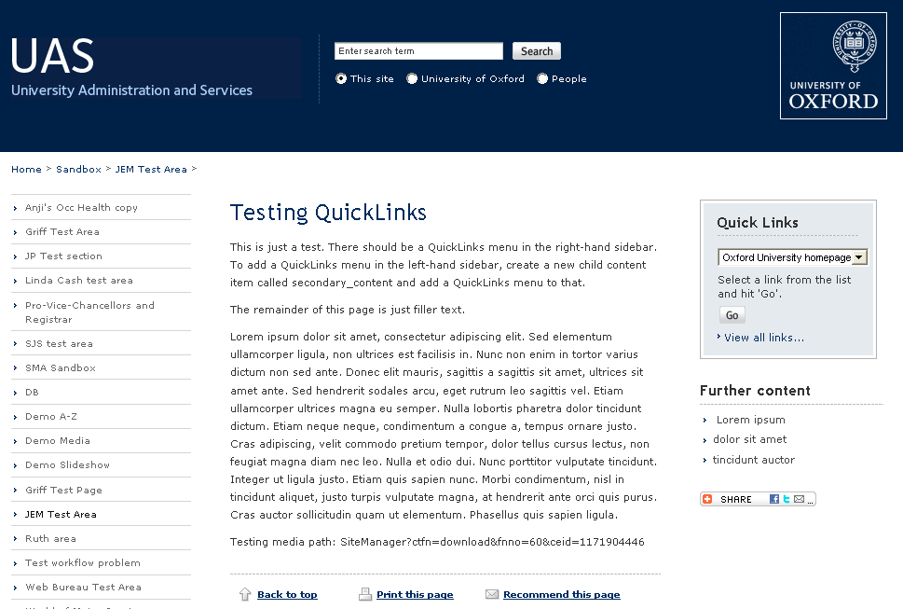

Non-linked headings may be included by adding an item to the bulleted list which is not a hyperlink.

## 26. Gl Slideshow

The Gl Slideshow template is used to add a slideshow of images (which have previously been uploaded to SlideShowPro) to a page.

**Note**: Flash is required both for authoring and viewing SlideShowPro slideshows.

### Creating a Slideshow in SlideShowPro:

To create a SlideShowPro slideshow, you need to log onto to SlideShowPro at <http://uasweb.slideshowpro.com/> using the following credentials:

**Username** = UASslides

**Password** = Uas1w3bcms

*Please only use this account to look, or upload your own content, and don’t change any existing content or global settings.*

1. Once logged in, to create a new album, follow the *Create a new album* link under the *Shortcuts* list of options on the left of the screen. Make sure that the *Edit album after it has been created* tickbox is selected.
2. Under the *Add content* section, ensure *content* is selected in the dropdown list and click the *Browse* button to select content to upload.
3. Browse to the image that you would like to include in the slideshow. You can upload multiple files at one time.
4. When you have selected all the images you wish to upload, click the *upload* button.
5. SlideShowPro will now upload and process your files. If you have a large number of files and/or large file, this may take a few moments.
6. Your album has now been created. You should now see thumbnails of all the images you selected, in the order they were uploaded. If you wish to rearrange the order of the images you can do so here by dragging image around.

In case you would like to convert a Power Point slideshow into a slideshow in Slideshow Pro, first you need to save the Power Point slides as images.

In order to extract the slides as pictures from the PPT slideshow, you have to choose ‘File -> Save As’ and select .jpeg from the File Format drop down.

PowerPoint will automatically extract every picture embedded in the PPT file and save it to the selected folder.

You can then use these pictures in Slideshow Pro as explained above.

1. 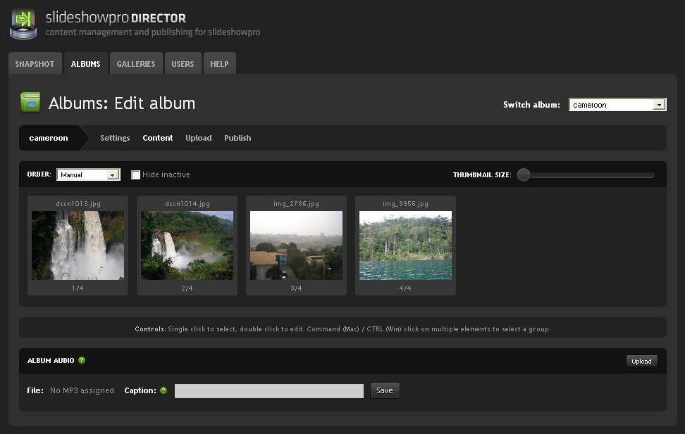
2. Selecting the *settings* tab will give you a range of options for your slideshow. Among these is the **xml file path**. This is the url that is needed for the *Gl Slideshow* template. Clicking the *copy* button associated with the **xml file path** will place the url onto your clipboard.

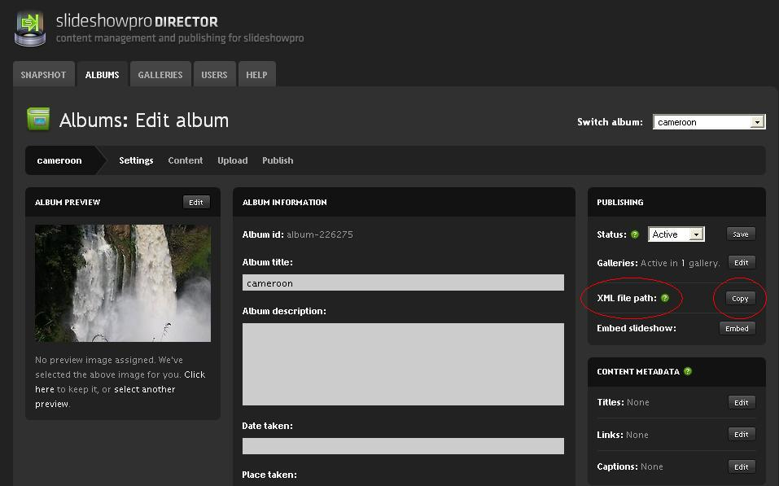

The url should look something like this - <http://uasweb.slideshowpro.com/images.php?album=226263>

You can then paste this into the **Slideshow Location** field in the **‘*Gl Slideshow’*** template (see below).

### Adding a Slideshow using the Gl Slideshow template:

Having created a SlideShowPro slideshow (see above), you can then use the **‘*Gl Slideshow’*** template to embed the slideshow in your page. To do this, you will need the **xml file path** of the SlideShowPro slideshow to include in the **Slideshow Location** field of the template (see SlideShowPro instructions above for how to get this url).

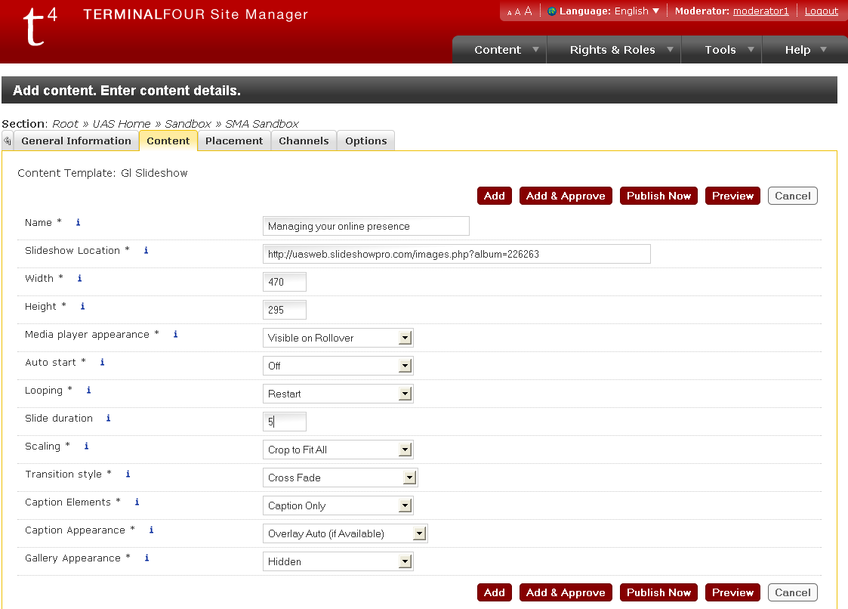

The **Width** and **Height** fields determine the width and height of the slideshow (in pixels). As a guide, the standard size of a slideshow on the main University site is 470 x 295.

Many users may only need concern themselves with the **Slideshow Location**, **Width** and **Height** fields. However the template has been set up to allow users to specify various SlideShowPro parameters within the template form. Further details follow:

The **Media player appearance** field determines how and whether the Slideshow controls are displayed.

The **Auto start** field determines whether or not the Slideshow starts when the page loads.

The **Looping** field determines the Slideshow's behaviour at the end of the Slideshow, whether it stops, restarts or switches to the next Slideshow. The default is *stop*.

The **Slide duration** field determines how long each slide is displayed for.

The **Scaling** field determines how SlideshowPro handles slides of different shapes and sizes.

The **Transition style** field determines the style of transitions between slides. Available options are "None", "Blur", "Cross Fade", "Fade to Background", "Dissolve", "Drop" "Lens", "Photo Flash", "Push", "Wipe", "Wipe and Fade", "Wipe to Background" and "Wipe and Fade to Background". The default value is "Cross Fade".

The **Caption Elements** field determines which elements of the caption are displayed (*Header only*, *caption only* or *header and caption*).

The **Caption Appearance** field determines the appearance of the caption. The options are "Hidden", "Fixed", "Fixed (if Available)", "Fixed on Rollover", "Fixed on Rollover (if Available)", "Inline", "Overlay on Rollover", "Overlay on Rollover (if Available)", "Overlay Auto", and "Overlay Auto (if Available)". The default value is "Overlay on Rollover (if Available)".

The **Gallery Appearance** field determines whether or not the gallery browsing button is displayed. The default is *hidden*

In addition, the following templates, for general use, are earmarked for development. URLs of similar pages show indicative examples of the type of content these templates will provide. (The exact layouts may differ.)

* **Gl News:**
  + <http://www.ox.ac.uk/media/>
* **Gl Events:**
  + <http://www.ox.ac.uk/visitors_friends/whats_on/>
* **Gl Landing page:**
  + <http://www.ox.ac.uk/colleges/colleges_and_halls_az/oriel.html>
* **Gl Enquiry Form:**
  + <http://www.ox.ac.uk/applications/dynamic/contact_us.rm?id=164&area=root&backto=1>
* **Gl Calendar:**

